Name: B.Vinayani
Registration Number: 192472179

EXPERIMENT 4
Zero-shot, One-shot and Few-shot Prompts - Professional Leave Request Email (Illness)

AIM
To design zero-shot, one-shot and few-shot prompts for generating a professional email requesting leave due to illness and to compare the emails on tone, grammar, formatting and completeness.

PROCEDURE
1. Open an LLM chat interface (such as ChatGPT, Gemini or Claude) in a new chat.
2. Zero-shot: enter an instruction that describes only the task (write a professional email requesting leave due to illness) without any example, and note the response.
3. One-shot: start a new chat and enter the same instruction together with ONE worked example, followed by the actual task. Note the response.
4. Few-shot: start a new chat and enter the same instruction together with THREE worked examples, followed by the actual task. Note the response.
5. Capture a screenshot of each prompt with its generated output.
6. Compare the three outputs and record the observations.

PROMPTS (CODE)
Zero-shot prompt:
Write a professional email requesting leave due to illness.

One-shot prompt:
Write a professional email requesting leave due to illness. Follow the format of the example.

Example:
Subject: Request for Casual Leave - 12 March

Dear Mr. Rao,

I would like to request casual leave on 12 March 2026 to attend a family function. I have completed my pending reports and Ms. Priya has agreed to cover my tasks for the day.

Kindly approve my request.

Thank you.

Sincerely,
Anita Kumar
Employee ID: 4521

Now write the email for: sick leave for 3 days (24-26 October 2026) due to fever; manager: Mr. Menon; employee: Vinayani, ID 5012.

Few-shot prompt:
Write a professional email requesting leave due to illness. Follow the format of the examples.

Example 1:
Subject: Request for Casual Leave - 12 March

Dear Mr. Rao,

I would like to request casual leave on 12 March 2026 to attend a family function. I have completed my pending reports and Ms. Priya has agreed to cover my tasks for the day.

Kindly approve my request.

Thank you.

Sincerely,
Anita Kumar
Employee ID: 4521

Example 2:
Subject: Request for Leave - Medical Appointment

Dear Ms. Sharma,

I am writing to request half-day leave on 5 June 2026 as I have a medical appointment in the afternoon. I will be back the next morning and will share my pending updates before leaving.

I would be grateful for your approval.

Regards,
Rohit Verma
Employee ID: 3187

Example 3:
Subject: Leave Request - Personal Emergency

Dear Mr. Das,

Due to an urgent personal matter, I need to take leave on 18 and 19 August 2026. I will keep my phone available for any critical queries, and my teammate Karan will manage my responsibilities.

Thank you for your understanding.

Yours sincerely,
Sana Khan
Employee ID: 2764

Now write the email for: sick leave for 3 days (24-26 October 2026) due to fever; manager: Mr. Menon; employee: Vinayani, ID 5012.

OUTPUT
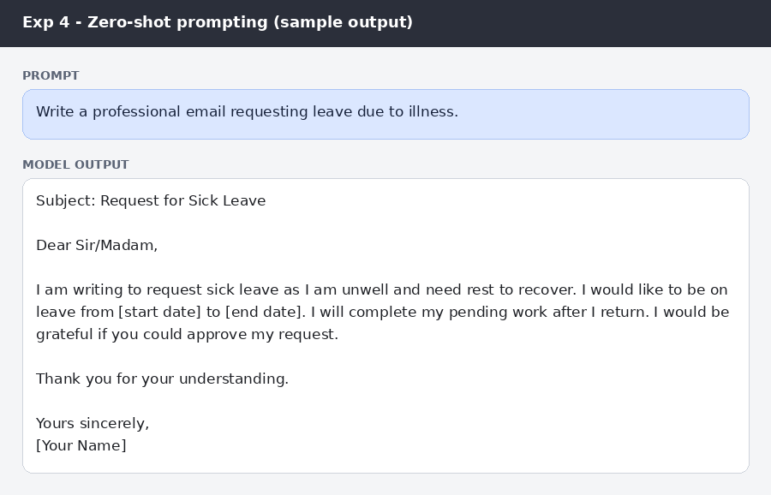
Figure: Zero-shot prompt and sample email
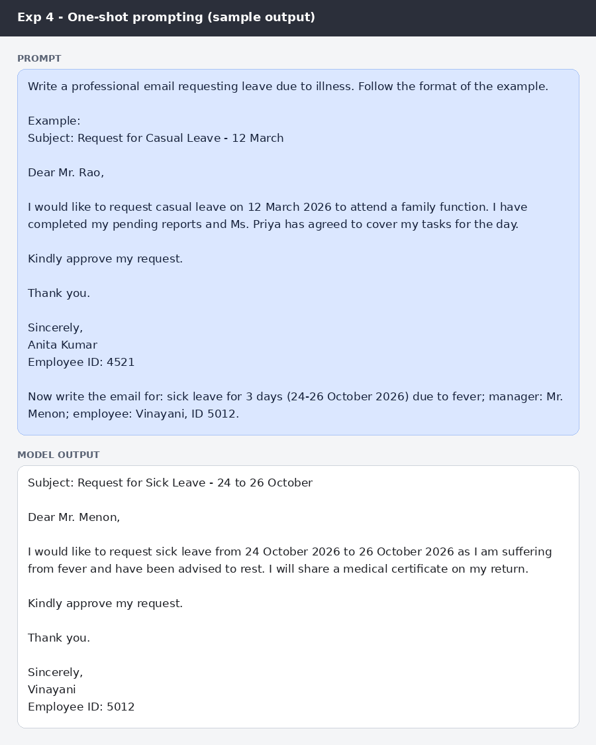
Figure: One-shot prompt and sample email
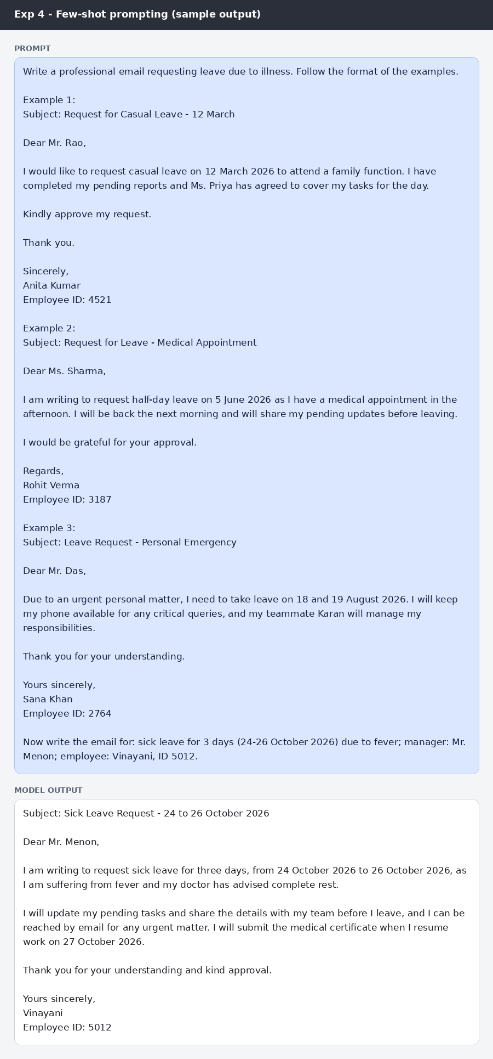
Figure: Few-shot prompt and sample email
Comparison of the generated emails
Criteria | Zero-shot | One-shot | Few-shot
Tone | Polite but generic ('Dear Sir/Madam') | Polite and formal; addressed to the manager by name | Polite, formal and courteous; closes with thanks for approval
Grammar | Correct | Correct | Correct
Formatting | Subject, greeting, body, closing; placeholders for dates and name; no employee ID | Subject with dates, greeting, short body, closing, name and employee ID | Subject with dates, three clear paragraphs, closing, name and employee ID
Completeness | Reason is vague (unwell); no dates, name or ID filled in | Dates, reason (fever) and medical certificate; no work hand-over or contact detail | Dates, reason, doctor's advice, hand-over of work, availability by email, certificate and return date

RESULT
All three emails were grammatically correct and used a polite, formal tone. The zero-shot email was generic and left placeholders for the dates and name. The one-shot email filled in the dates, reason, name and ID in the format of the example. The few-shot email was the most complete: it added the doctor's advice, work hand-over, availability for urgent matters, the medical certificate and the date of return.

CONCLUSION
Examples improve the personalisation, formatting and completeness of a professional email while the tone and grammar remain good in every case. Few-shot prompting produced the most ready-to-send email.

